DATA ANALYSIS AND FORECASTING

KOVAI.CO

KEY INSIGHTS :
- Strong Seasonal Patterns Across All Major Routes:
The ridership clearly rises and falls in a repeating yearly pattern across
Local, Light Rail, Rapid, and School routes, showing strong seasonality.
The School route especially stands out, with sharp increases during school
months and noticeable drops during vacation periods, which matches real-
world academic schedules.
- A Significant Structural Break Occurred Around Early 2020: All services show a sharp and sudden drop in early 2020, which aligns with the onset of COVID-19 restrictions and major changes in travel behavior. The histograms also reflect this shift, with one cluster showing normal ridership before and after COVID, and another showing the dramatically reduced ridership during 2020–2021.
- Rapid Route is the Dominant: The Rapid Route consistently carries the highest number of passengers and shows large swings throughout the timeline. Its wide distribution range suggests it responds strongly to seasonal changes and external events, making it the most sensitive and heavily used service.
- Peak Service and Other Routes Have Very Low and Stable Ridership: Both Peak Service and Other routes remain almost flat over time, showing minimal changes in usage. Their distributions are tightly packed at low values, indicating these services cater to small, stable groups of passengers.

- Strong Recovery and Growth After 2022: Ridership across the major services begins climbing steadily from mid-2022, showing a clear return of demand. By 2023–2024, the Local and Rapid routes even surpass their pre-2020 levels, suggesting strong recovery and possibly increased adoption..

MONTHLY AVERAGE PASSENGER JOURNEYS BY SERVICE:

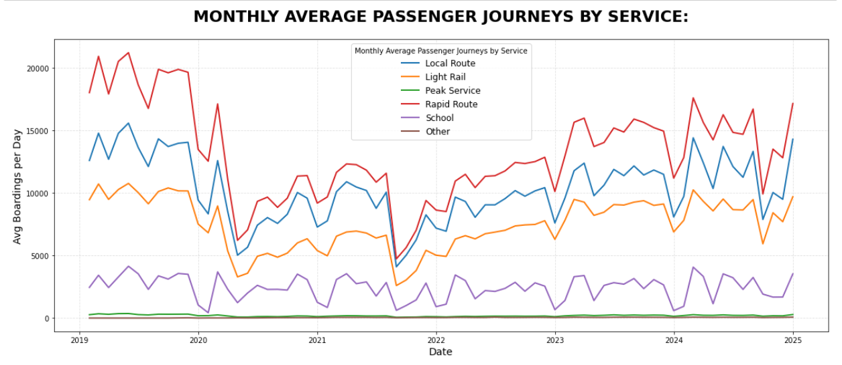

FORECASTING FOR NEXT 7-DAYS:

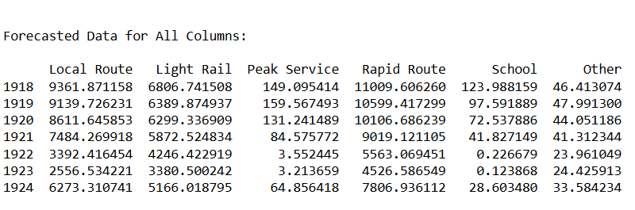

THANK YOU!

